Exception Handling in Java

The **Exception Handling in Java** is one of the powerful *mechanisms to handle the runtime errors* so that the normal flow of the application can be maintained.

In this tutorial, we will learn about Java exceptions, it's types, and the difference between checked and unchecked exceptions.

What is Exception in Java?

**Dictionary Meaning:** Exception is an abnormal condition.

In Java, an exception is an event that disrupts the normal flow of the program. It is an object which is thrown at runtime.

What is Exception Handling?

Exception Handling is a mechanism to handle runtime errors such as ClassNotFoundException, IOException, SQLException, RemoteException, etc.

1. statement 1;
2. statement 2;
3. statement 3;
4. statement 4;
5. statement 5;//exception occurs
6. statement 6;
7. statement 7;
8. statement 8;
9. statement 9;
10. statement 10;

Suppose there are 10 statements in a Java program and an exception occurs at statement 5; the rest of the code will not be executed, i.e., statements 6 to 10 will not be executed. However, when we perform exception handling, the rest of the statements will be executed. That is why we use exception handling in [Java](https://www.javatpoint.com/java-tutorial).

Hierarchy of Java Exception classes

The java.lang.Throwable class is the root class of Java Exception hierarchy inherited by two subclasses: Exception and Error. The hierarchy of Java Exception classes is given below:

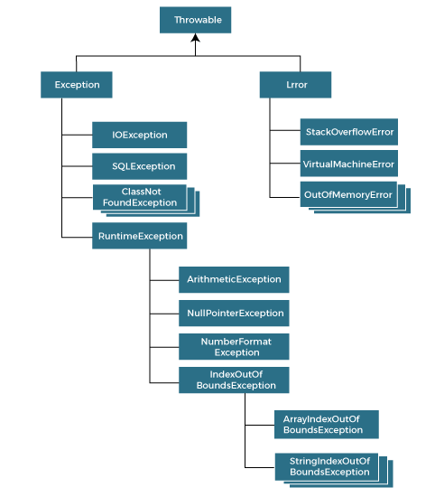

### **Types of Java Exceptions**

There are mainly two types of exceptions: checked and unchecked. An error is considered as the unchecked exception. However, according to Oracle, there are three types of exceptions namely:

1. Checked Exception
2. Unchecked Exception
3. Error

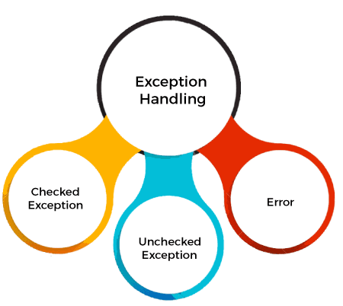

## Difference between Checked and Unchecked Exceptions

### **1) Checked Exception**

The classes that directly inherit the Throwable class except RuntimeException and Error are known as checked exceptions. For example, IOException, SQLException, etc. Checked exceptions are checked at compile-time.

### **2) Unchecked Exception**

The classes that inherit the RuntimeException are known as unchecked exceptions. For example, ArithmeticException, NullPointerException, ArrayIndexOutOfBoundsException, etc. Unchecked exceptions are not checked at compile-time, but they are checked at runtime.

### **3) Error**

Error is irrecoverable. Some example of errors are OutOfMemoryError, VirtualMachineError, AssertionError etc.

## Java Exception Keywords

Java provides five keywords that are used to handle the exception. The following table describes each.

|  |  |
| --- | --- |
| **Keyword** | **Description** |
| try | The "try" keyword is used to specify a block where we should place an exception code. It means we can't use try block alone. The try block must be followed by either catch or finally. |
| catch | The "catch" block is used to handle the exception. It must be preceded by try block which means we can't use catch block alone. It can be followed by finally block later. |
| finally | The "finally" block is used to execute the necessary code of the program. It is executed whether an exception is handled or not. |
| throw | The "throw" keyword is used to throw an exception. |
| throws | The "throws" keyword is used to declare exceptions. It specifies that there may occur an exception in the method. It doesn't throw an exception. It is always used with method signature. |

## Java Exception Handling Example

Let's see an example of Java Exception Handling in which we are using a try-catch statement to handle the exception.

**JavaExceptionExample.java**

1. **public** **class** JavaExceptionExample{
2. **public** **static** **void** main(String args[]){
3. **try**{
4. //code that may raise exception
5. **int** data=100/0;
6. }**catch**(ArithmeticException e){System.out.println(e);}
7. //rest code of the program
8. System.out.println("rest of the code...");
9. }
10. }

**Output:**

Exception in thread main java.lang.ArithmeticException:/ by zero

rest of the code...

In the above example, 100/0 raises an ArithmeticException which is handled by a try-catch block.

## Common Scenarios of Java Exceptions

There are given some scenarios where unchecked exceptions may occur. They are as follows:

### **1) A scenario where ArithmeticException occurs**

If we divide any number by zero, there occurs an ArithmeticException.

1. **int** a=50/0;//ArithmeticException

### **2) A scenario where NullPointerException occurs**

If we have a null value in any [variable](https://www.javatpoint.com/java-variables), performing any operation on the variable throws a NullPointerException.

1. String s=**null**;
2. System.out.println(s.length());//NullPointerException

### **3) A scenario where NumberFormatException occurs**

If the formatting of any variable or number is mismatched, it may result into NumberFormatException. Suppose we have a [string](https://www.javatpoint.com/java-string) variable that has characters; converting this variable into digit will cause NumberFormatException.

1. String s="abc";
2. **int** i=Integer.parseInt(s);//NumberFormatException

### **4) A scenario where ArrayIndexOutOfBoundsException occurs**

When an array exceeds to it's size, the ArrayIndexOutOfBoundsException occurs. there may be other reasons to occur ArrayIndexOutOfBoundsException. Consider the following statements.

1. **int** a[]=**new** **int**[5];
2. a[10]=50; //ArrayIndexOutOfBoundsException

## Java try block

Java **try** block is used to enclose the code that might throw an exception. It must be used within the method.

If an exception occurs at the particular statement in the try block, the rest of the block code will not execute. So, it is recommended not to keep the code in try block that will not throw an exception.

Java try block must be followed by either catch or finally block.

### **Syntax of Java try-catch**

1. **try**{
2. //code that may throw an exception
3. }**catch**(Exception_class_Name ref){}

### **Syntax of try-finally block**

1. **try**{
2. //code that may throw an exception
3. }**finally**{}

## Java catch block

Java catch block is used to handle the Exception by declaring the type of exception within the parameter. The declared exception must be the parent class exception ( i.e., Exception) or the generated exception type. However, the good approach is to declare the generated type of exception.

The catch block must be used after the try block only. You can use multiple catch block with a single try block.

Internal Working of Java try-catch block

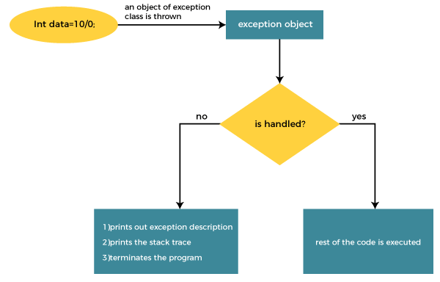

The JVM firstly checks whether the exception is handled or not. If exception is not handled, JVM provides a default exception handler that performs the following tasks:

* Prints out exception description.
* Prints the stack trace (Hierarchy of methods where the exception occurred).
* Causes the program to terminate.

But if the application programmer handles the exception, the normal flow of the application is maintained, i.e., rest of the code is executed.

## Problem without exception handling

Let's try to understand the problem if we don't use a try-catch block.

### **Example 1**

**TryCatchExample1.java**

**public** **class** TryCatchExample1 {

**public** **static** **void** main(String[] args) {

**int** data=50/0; //may throw exception

        System.out.println("rest of the code");

    }

}

## Solution by exception handling

Let's see the solution of the above problem by a java try-catch block.

### **Example 2**

**TryCatchExample2.java**

1. **public** **class** TryCatchExample2 {
3. **public** **static** **void** main(String[] args) {
4. **try**
5. {
6. **int** data=50/0; //may throw exception
7. }
8. //handling the exception
9. **catch**(ArithmeticException e)
10. {
11. System.out.println(e);
12. }
13. System.out.println("rest of the code");
14. }
15. }

# Java Catch Multiple Exceptions

## Java Multi-catch block

A try block can be followed by one or more catch blocks. Each catch block must contain a different exception handler. So, if you have to perform different tasks at the occurrence of different exceptions, use java multi-catch block.

## Points to remember

* At a time only one exception occurs and at a time only one catch block is executed.
* All catch blocks must be ordered from most specific to most general, i.e. catch for ArithmeticException must come before catch for Exception.

### **Flowchart of Multi-catch Block**

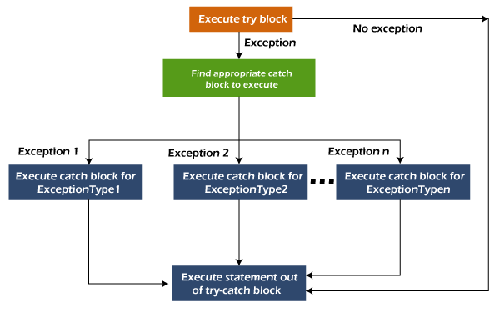

### **Example 1**

Let's see a simple example of java multi-catch block.

**MultipleCatchBlock1.java**

1. **public** **class** MultipleCatchBlock1 {
3. **public** **static** **void** main(String[] args) {
5. **try**{
6. **int** a[]=**new** **int**[5];
7. a[5]=30/0;
8. }
9. **catch**(ArithmeticException e)
10. {
11. System.out.println("Arithmetic Exception occurs");
12. }
13. **catch**(ArrayIndexOutOfBoundsException e)
14. {
15. System.out.println("ArrayIndexOutOfBounds Exception occurs");
16. }
17. **catch**(Exception e)
18. {
19. System.out.println("Parent Exception occurs");
20. }
21. System.out.println("rest of the code");
22. }
23. }

**Output**

Arithmetic Exception occurs

rest of the code

**MultipleCatchBlock2.java**

1. **public** **class** MultipleCatchBlock2 {
3. **public** **static** **void** main(String[] args) {
5. **try**{
6. **int** a[]=**new** **int**[5];
8. System.out.println(a[10]);
9. }
10. **catch**(ArithmeticException e)
11. {
12. System.out.println("Arithmetic Exception occurs");
13. }
14. **catch**(ArrayIndexOutOfBoundsException e)
15. {
16. System.out.println("ArrayIndexOutOfBounds Exception occurs");
17. }
18. **catch**(Exception e)
19. {
20. System.out.println("Parent Exception occurs");
21. }
22. System.out.println("rest of the code");
23. }
24. }

**Output:**

ArrayIndexOutOfBounds Exception occurs

rest of the code

# Java Nested try block

In Java, using a try block inside another try block is permitted. It is called as nested try block. Every statement that we enter a statement in try block, context of that exception is pushed onto the stack.

For example, the **inner try block** can be used to handle **ArrayIndexOutOfBoundsException** while the **outer try block** can handle the **ArithemeticException** (division by zero).

### **Why use nested try block**

Sometimes a situation may arise where a part of a block may cause one error and the entire block itself may cause another error. In such cases, exception handlers have to be nested.

### **Syntax:**

....

//main try block

**try**

{

    statement 1;

    statement 2;

//try catch block within another try block

**try**

    {

        statement 3;

        statement 4;

//try catch block within nested try block

**try**

        {

            statement 5;

            statement 6;

     }

**catch**(Exception e2)

        {

//exception message

        }

    }

**catch**(Exception e1)

    {

//exception message

    }

}

//catch block of parent (outer) try block

**catch**(Exception e3)

{

//exception message

}

....

**Example of nested try block**

**public** **class** NestedTryBlock{

**public** **static** **void** main(String args[]){

 //outer try block

**try**{

  //inner try block 1

**try**{

     System.out.println("going to divide by 0");

**int** b =39/0;

   }

    //catch block of inner try block 1

**catch**(ArithmeticException e)

    {

      System.out.println(e);

    }

    //inner try block 2

**try**{

**int** a[]=**new** **int**[5];

    //assigning the value out of array bounds

     a[5]=4;

     }

      //catch block of inner try block 2

**catch**(ArrayIndexOutOfBoundsException e)

    {

       System.out.println(e);

    }

    System.out.println("other statement");

  }

  //catch block of outer try block

**catch**(Exception e)

  {

    System.out.println("handled the exception (outer catch)");

  }

  System.out.println("normal flow..");

 }

}

**Output:**

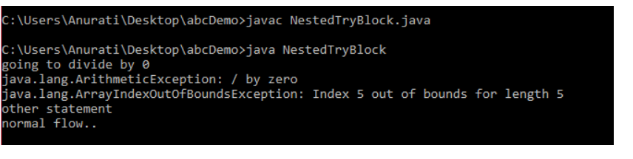

When any try block does not have a catch block for a particular exception, then the catch block of the outer (parent) try block are checked for that exception, and if it matches, the catch block of outer try block is executed.

If none of the catch block specified in the code is unable to handle the exception, then the Java runtime system will handle the exception. Then it displays the system generated message for that exception.

# Java finally block

**Java finally block** is a block used to execute important code such as closing the connection, etc.

Java finally block is always executed whether an exception is handled or not. Therefore, it contains all the necessary statements that need to be printed regardless of the exception occurs or not.

The finally block follows the try-catch block.

### **Flowchart of finally block**

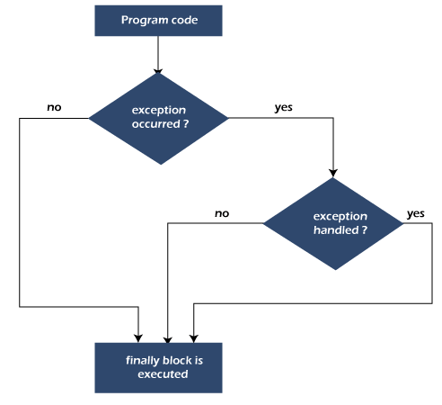

#### **Note: If you don't handle the exception, before terminating the program, JVM executes finally block (if any).**

## Why use Java finally block?

* finally block in Java can be used to put "**cleanup**" code such as closing a file, closing connection, etc.
* The important statements to be printed can be placed in the finally block.

## Usage of Java finally

Let's see the different cases where Java finally block can be used.

### **Case 1: When an exception does not occur**

Let's see the below example where the Java program does not throw any exception, and the finally block is executed after the try block.

**TestFinallyBlock.java**

1. **class** TestFinallyBlock {
2. **public** **static** **void** main(String args[]){
3. **try**{
4. //below code do not throw any exception
5. **int** data=25/5;
6. System.out.println(data);
7. }
8. //catch won't be executed
9. **catch**(NullPointerException e){
10. System.out.println(e);
11. }
12. //executed regardless of exception occurred or not
13. **finally** {
14. System.out.println("finally block is always executed");
15. }
17. System.out.println("rest of the code...");
18. }
19. }

# Java throw Exception

In Java, exceptions allows us to write good quality codes where the errors are checked at the compile time instead of runtime and we can create custom exceptions making the code recovery and debugging easier.

## Java throw keyword

The Java throw keyword is used to throw an exception explicitly.

We specify the **exception** object which is to be thrown. The Exception has some message with it that provides the error description. These exceptions may be related to user inputs, server, etc.

We can throw either checked or unchecked exceptions in Java by throw keyword. It is mainly used to throw a custom exception. We will discuss custom exceptions later in this section.

We can also define our own set of conditions and throw an exception explicitly using throw keyword. For example, we can throw ArithmeticException if we divide a number by another number. Here, we just need to set the condition and throw exception using throw keyword.

The syntax of the Java throw keyword is given below.

throw Instance i.e.,

1. **throw** **new** exception_class("error message");

Let's see the example of throw IOException.

1. **throw** **new** IOException("sorry device error");

Where the Instance must be of type Throwable or subclass of Throwable. For example, Exception is the sub class of Throwable and the user-defined exceptions usually extend the Exception class.

## Java throw keyword Example

### **Example 1: Throwing Unchecked Exception**

In this example, we have created a method named validate() that accepts an integer as a parameter. If the age is less than 18, we are throwing the ArithmeticException otherwise print a message welcome to vote.

**TestThrow1.java**

In this example, we have created the validate method that takes integer value as a parameter. If the age is less than 18, we are throwing the ArithmeticException otherwise print a message welcome to vote.

1. **public** **class** TestThrow1 {
2. //function to check if person is eligible to vote or not
3. **public** **static** **void** validate(**int** age) {
4. **if**(age<18) {
5. //throw Arithmetic exception if not eligible to vote
6. **throw** **new** ArithmeticException("Person is not eligible to vote");
7. }
8. **else** {
9. System.out.println("Person is eligible to vote!!");
10. }
11. }
12. //main method
13. **public** **static** **void** main(String args[]){
14. //calling the function
15. validate(13);
16. System.out.println("rest of the code...");
17. }
18. }

**Output:**